**Sentimental Analysis For Marketing**

**phase-3**

***We started building our project by loading the dataset, performing text preprocessing, and conducting analysis in Colab Notebook***.

**Sentimental Analysis with Python:**

To build a machine learning model to accurately classify whether customers are saying positive or negative.

Steps to build Sentiment Analysis Text Classifier in Python

***1. Data Preprocessing:***

As we are dealing with the text data, we need to preprocess it using word embeddings.

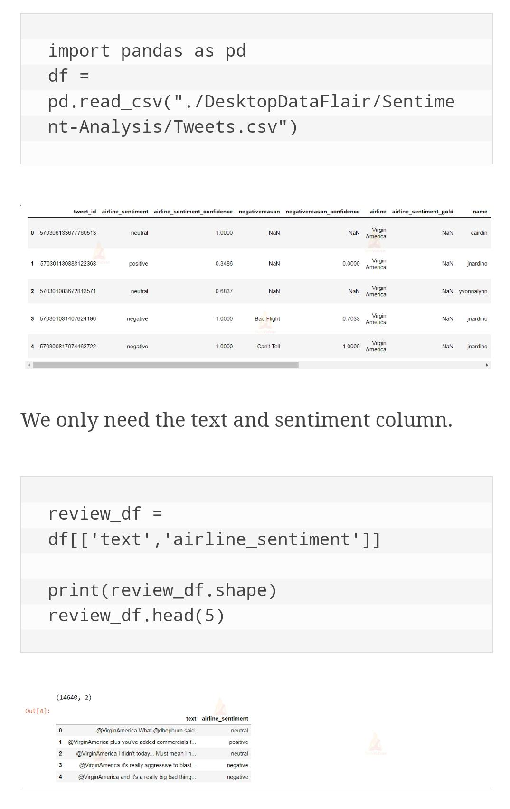

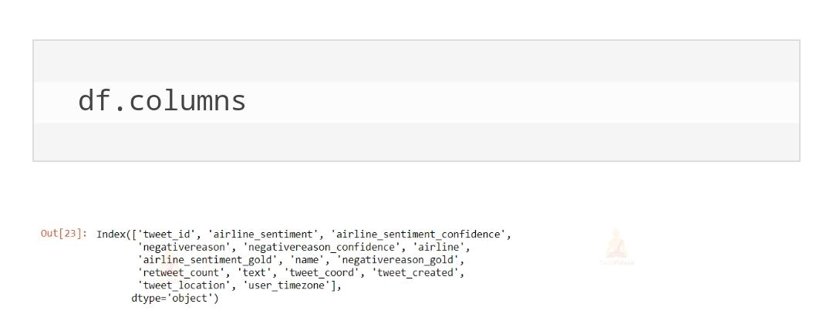

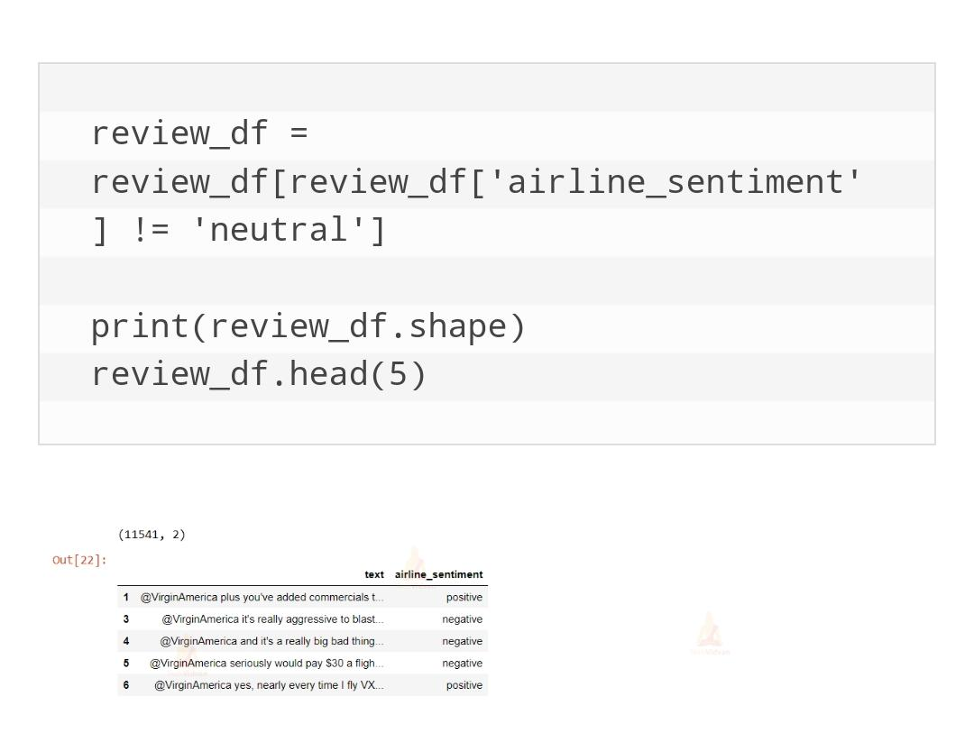

**The labels for this dataset are categorical. Machines understand only numeric data. So, convert the categorical values to numeric using the factorize() method. This returns an array of numeric values and an Index of categories.**

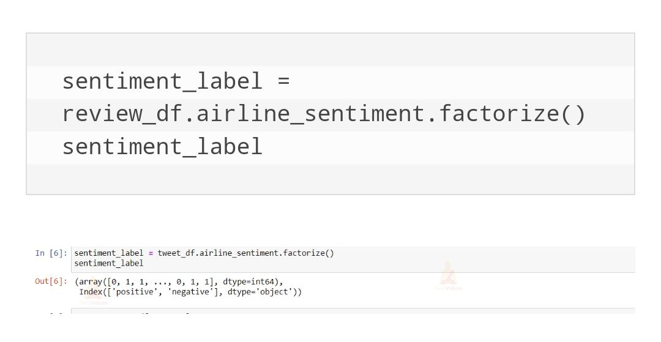

**2. Build the Text Classifier:**

For sentiment analysis project, we use LSTM layers in the machine learning model. The architecture of our model consists of an embedding layer, an LSTM layer, and a Dense layer at the end. To avoid overfitting, we introduced the Dropout mechanism in-between the LSTM layers.

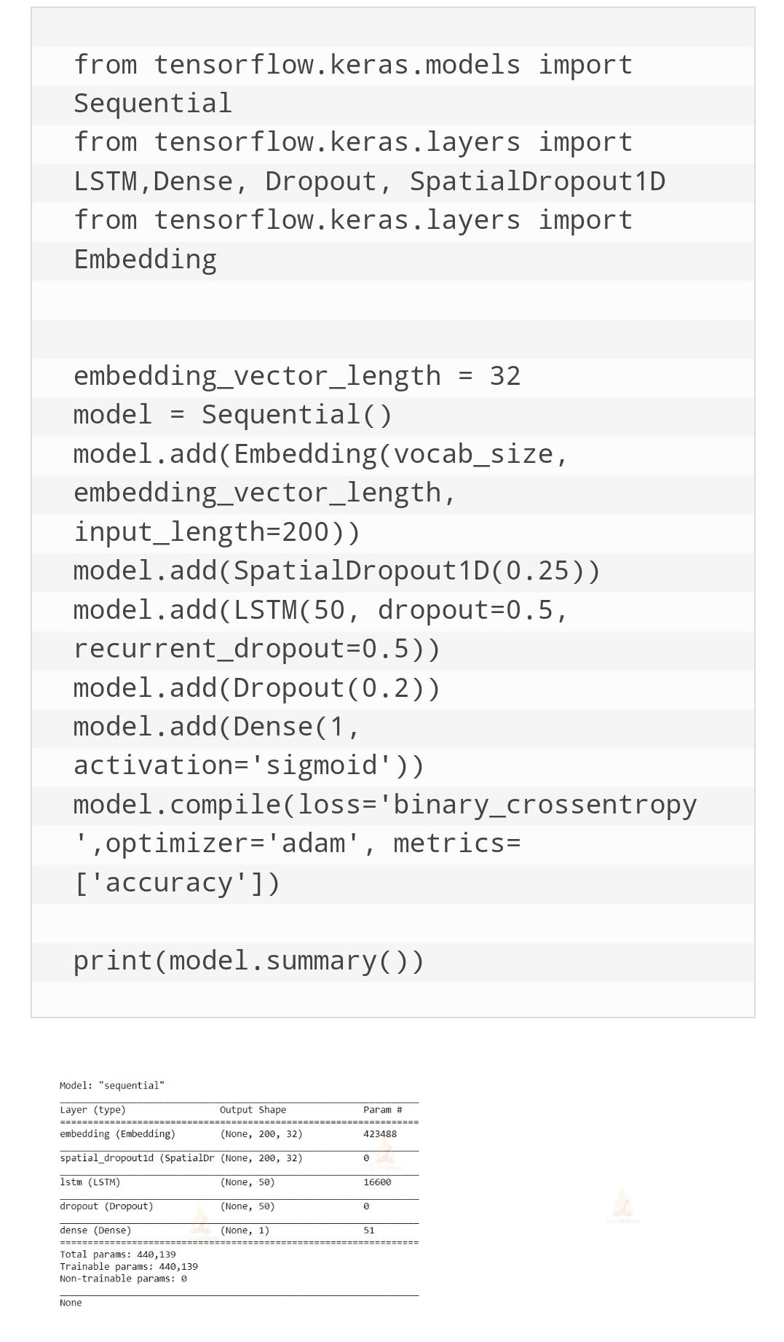

**3. Train the sentiment analysis model:**

Train the sentiment analysis model for 5 epochs on the whole dataset with a batch size of 32 and a validation split of 20%.

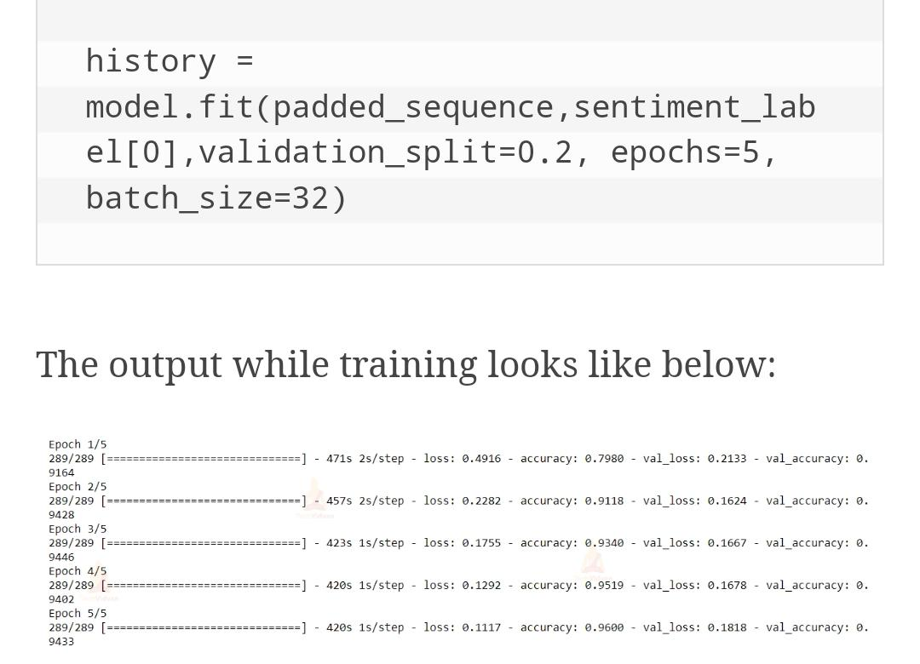

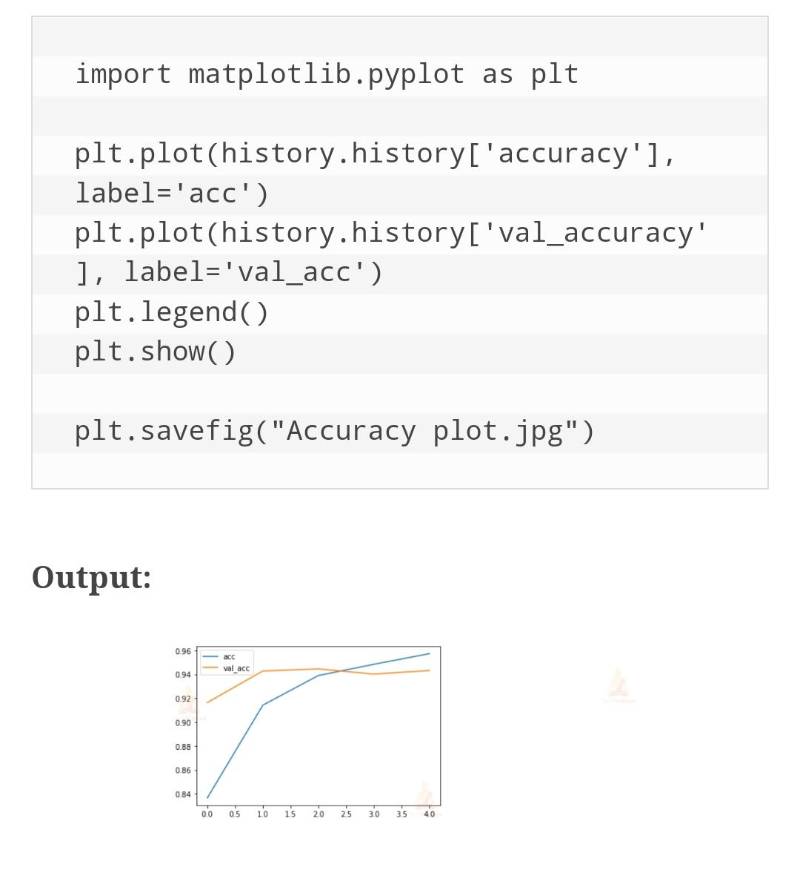

Let’s execute sentiment analysis model

Define a function that takes a text as input and outputs its prediction label.

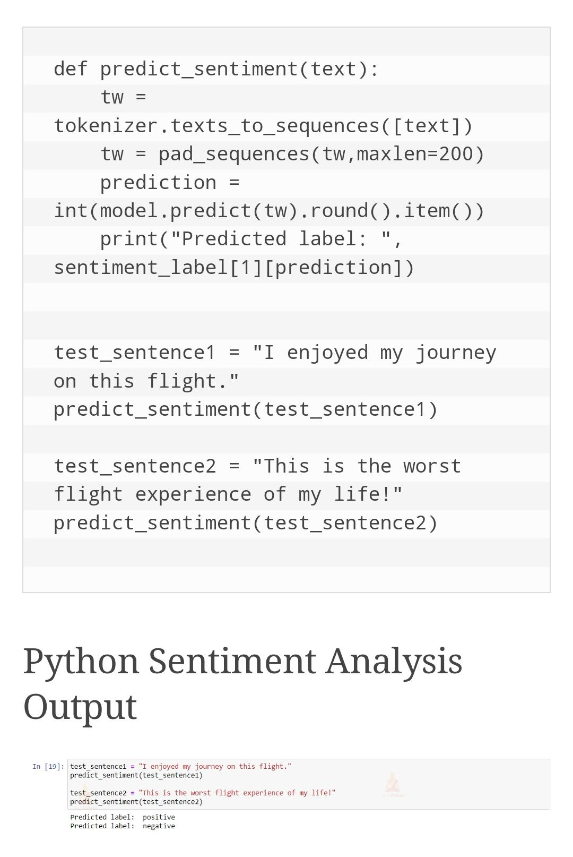

**Team Members:**

**I.JaharaAsmi**

**M.MuthuLakshmi**

**K.Santhiya**

**M.Shajitha Barveen**

**M.SathiyaJothi**